

Programming Fundamentals

Assignment No 8

Student Name :MOMIN HAYAT KHAN

Roll No: S20-0273

Department :BS(Artificial Intelligence)

Batch / Year:SPRING 2020

Lecturer: Mam Misbah

Program No 1:

A Distributor of a Pharmaceutical Company has 4 Districts, for supply the medicine. He requires a program that can display the sales of all his Districts. Write a Program in C++ Using two Dimensional Array that shows the Following Output. The Program should display the Sale, Districts wise and up to Months i.e

|  |
| --- |
| #include <iostream>  using namespace std;  int main()  {     int Districts=3;     int Months=3;     int d,m;     double sales[Districts][Months];     cout<<endl;     //storing values in array     for (int d = 0; d < Districts; d++)     {        for (int m = 0; m < Months; m++)        {           cout<<"Enter sales for district"<<d+1;           cout<<"month"<<m+1<<" : ";           cin>>sales[d][m];        }     }     //Displaying values stored in array     for ( d = 0; d < Districts; d++)     {        cout<<"\nDistrict "<<d+1;        for ( m = 0; m < Months; m++)        {           cout<<"  Month "<<m+1<<":";           cout<<sales[d][m];        }     }  } |

Output:

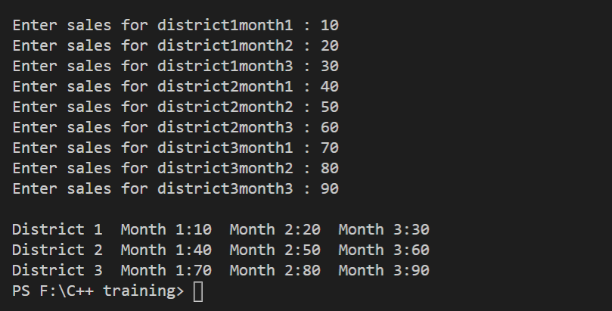

Program No 2:

Write a program in C++ that take two matrices and then Add them After inserting two matrices first display the both matrices and then add them and show the result. i.e

|  |
| --- |
| #include <iostream>  using namespace std;  int main()  {     int row=2;     int col=3;     double matrice[row][col];     int add=0;     //storing values     for (int r = 0; r < row; r++)     {        for (int c = 0; c < col; c++)        {           cout<<"Enter in Row "<<r+1;           cout<<" column "<<c+1<<" ";           cin>>matrice[r][c];        }       }     cout<<"--------------Displaying Values--------------------\n";     //displaying values     for (int D = 0; D < row; D++)     {        cout<<" Row "<<D+1;        for (int C = 0; C < col; C++)        {           cout<<" Column "<<C+1<<" : ";           cout<<matrice[D][C];        }     }       cout<<"\n\n--------------Adding Values--------------------\n";     for (int ro = 0; ro < row; ro++)     {        for (int co = 0; co < col; co++)        {           add+=matrice[ro][co];        }     }     cout<<endl<<"Addition of matrices = "<<add;  } |

Output:

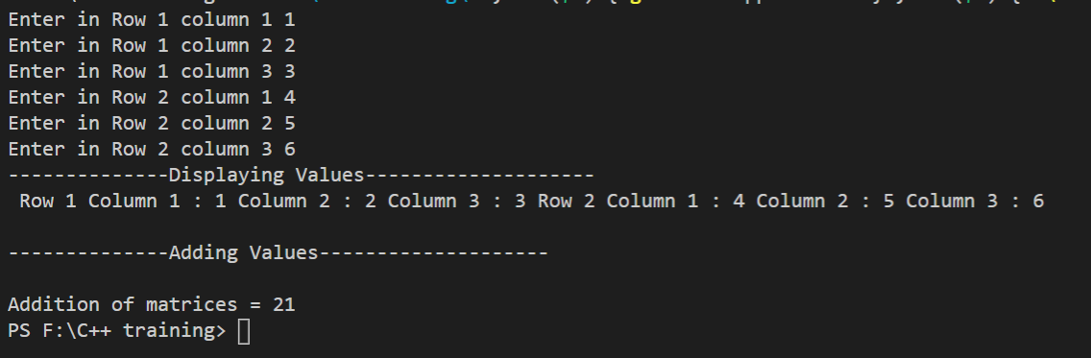

Program No 3:

Enter the values in a matrix and print it in reverse Column order.

|  |
| --- |
| #include <iostream>  using namespace std;  int main()  {     int row=2;     int col=3;     int matrice[row][col];     int add=0;     //storing values     for (int r = 0; r < row; r++)     {        for (int c = 0; c < col; c++)        {           cout<<"Enter in Row "<<r+1;           cout<<" column "<<c+1<<" ";           cin>>matrice[r][c];        }       }     cout<<"--------------Displaying Values--------------------\n";     //displaying values     for (int ro = 1; ro >= 0; ro--)     {        for (int co = 2; co >= 0; co--)        {           cout<<matrice[ro][co];        }     }  } |

Output:

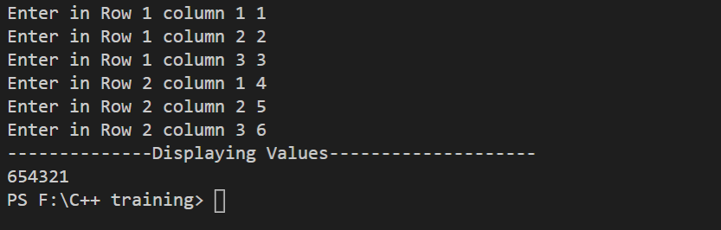

Program No 4:

Write a Program in C++ that Display the Transpose of a Matrix.

|  |
| --- |
| #include <iostream>  using namespace std;  int main()  {     int row=2;     int col=2;     int matrice[row][col];     int add=0;     //storing values     for (int r = 0; r < row; r++)     {        for (int c = 0; c < col; c++)        {           cout<<"Enter in Row "<<r+1;           cout<<" column "<<c+1<<" ";           cin>>matrice[r][c];        }       }     cout<<"-------------Transpose of matrix--------------------\n";     cout<<(matrice[0][0]*matrice[1][1])-(matrice[1][0]*matrice[0][1]);    } |

Output:

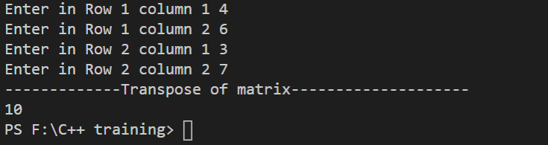

Program No 5:

Write a program in C++, which take Agent code (123,258,..) and Traveling expense (Rs = 5000, 6000,…) of the agent. Find the agent who had spent most money in all, Display the agent code and amount after searching in 2 D Array.

|  |
| --- |
| #include <iostream>  using namespace std;  int main()  {     int row=2;     int col=3;     int matrice[row][col];     //storing values     for (int c = 0; c < col; c++)     {        cout<<"Agent ID : "<<c+1<<" ";        cin>>matrice[0][c];     }     for (int c = 0; c < col; c++)     {        cout<<"Expenses : ";        cin>>matrice[1][c];     }  if (matrice[1][0]>matrice[1][1] && matrice[1][0]>matrice[1][2])  {   cout<<"Agent 1 ID NO ";   cout<<matrice[0][0]<<"  has greater expense.";  }  if (matrice[1][1]>matrice[1][2] && matrice[1][1]>matrice[1][0])  {   cout<<"Agent 2 ID NO ";   cout<<matrice[0][1]<<"  has greater expense.";  }  if (matrice[1][2]>matrice[1][0] && matrice[1][2]>matrice[1][1])  {   cout<<"Agent 3 ID NO ";   cout<<matrice[0][2]<<"  has greater expense.";  }  } |

Output:

